Lesson 11 Demo 1
Creating a Virtual Machine
Objective: To create a virtual machine

Tools required: Azure account with administrator access

Prerequisites: None

Steps to be followed:
- Creating a Virtual Machine
Step 1: Creating a Virtual Machine
1.1 Log in to the Azure portal at https://portal.azure.com

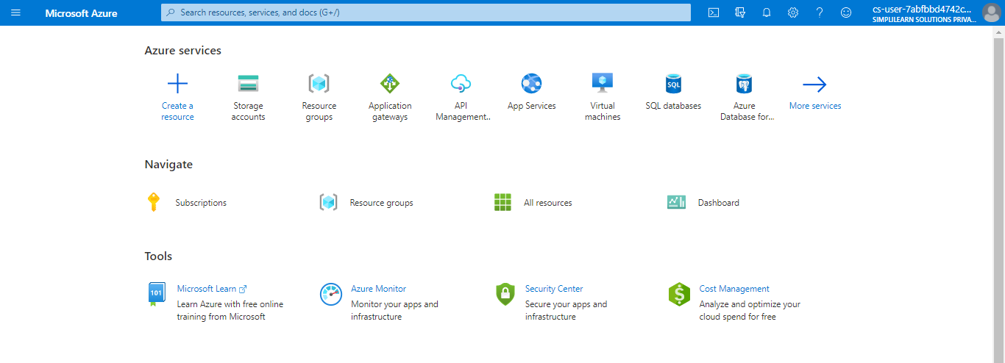

1.2 Type virtual machines in the search box

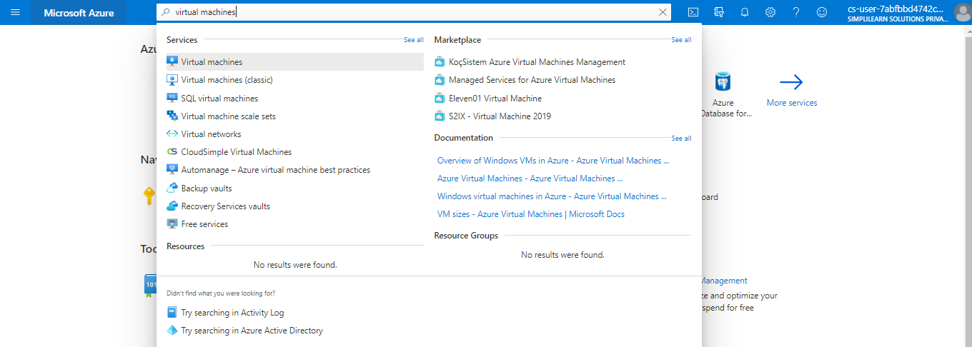

1.3 Under Services, select Virtual machines

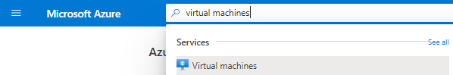

1.4 Click on Add > Virtual machine
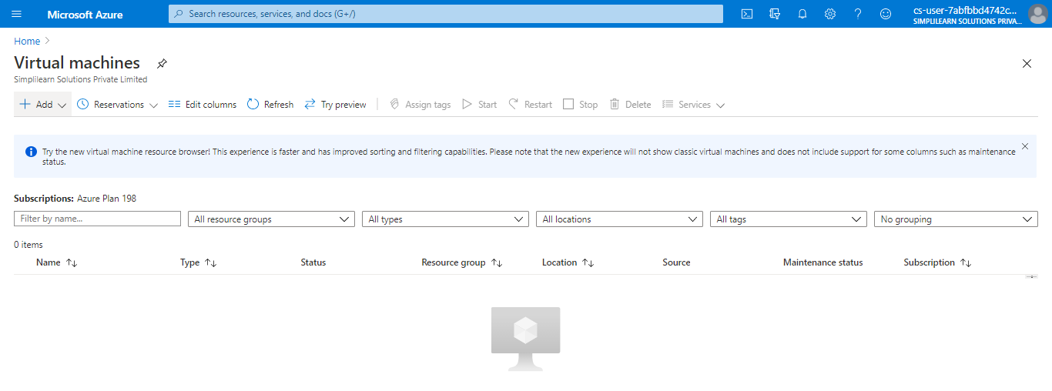

1.5 In the Basics tab, under Project details, make sure the correct subscription is selected and then choose a resource group or click on Create new to create a new resource group
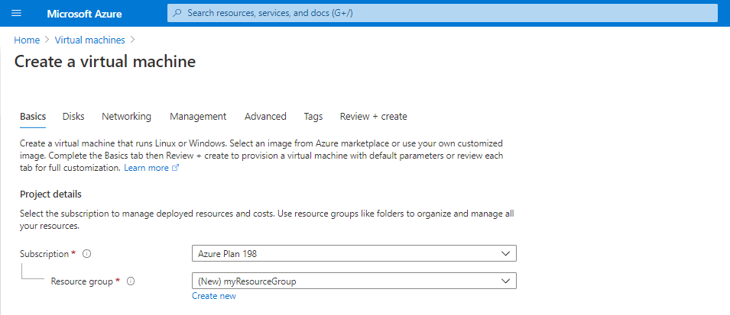

1.6 Under Instance details, type a name for the virtual machine, choose your Region, and then choose the image. Leave the others as default

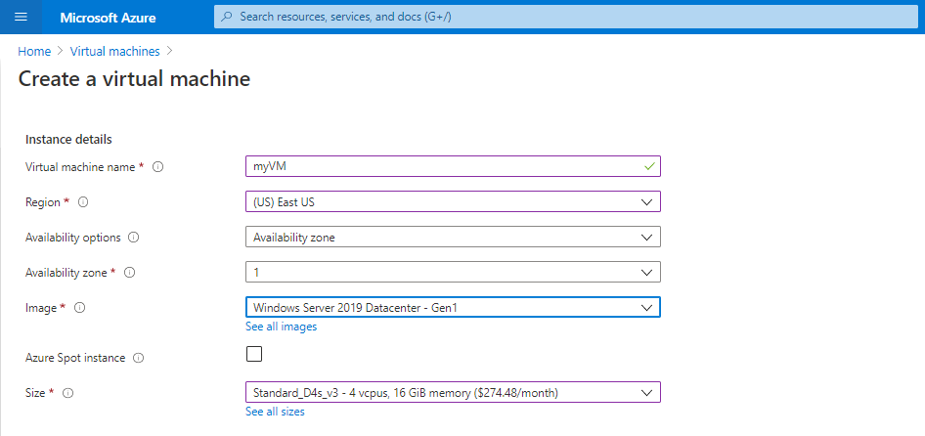
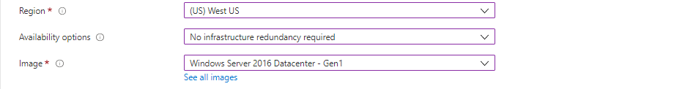

1.7 Under Administrator account, provide a username and password

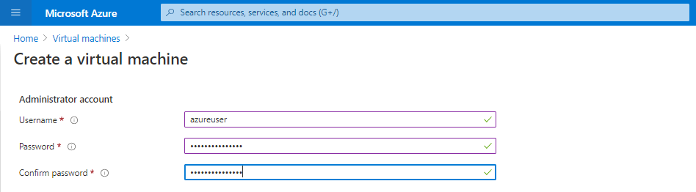

1.8 Under Inbound port rules, choose Allow selected ports

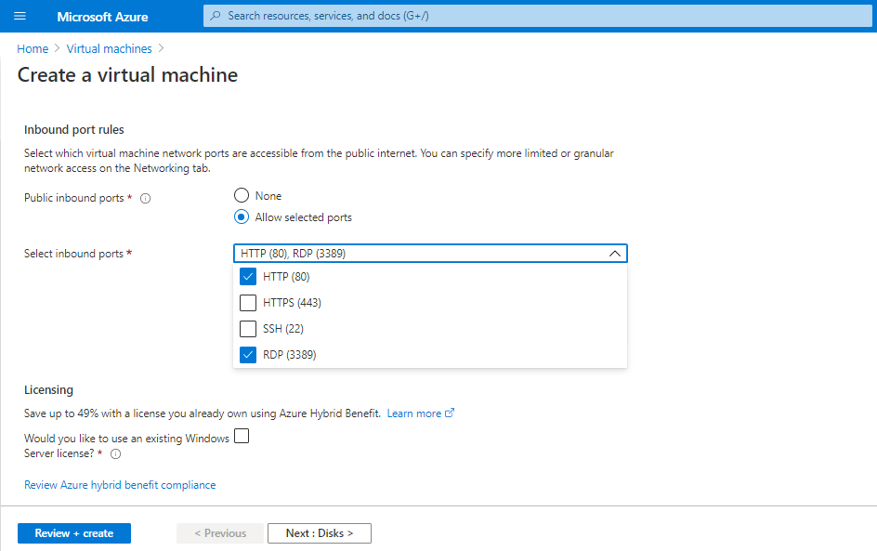
1.9 Leave the remaining as default
1.10 Click on Review + create
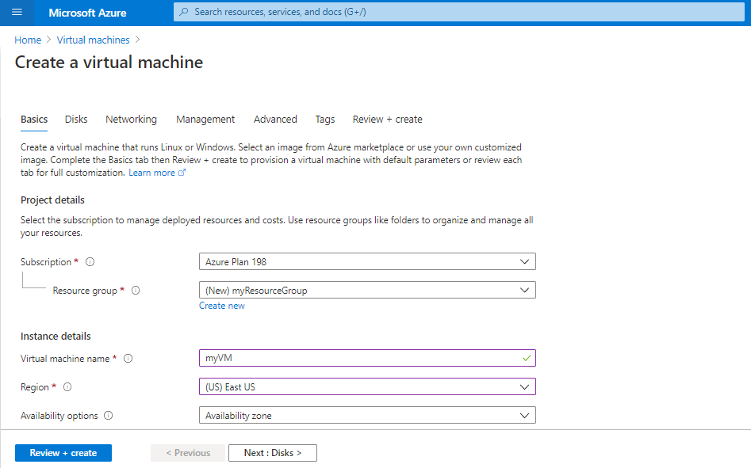



1.11 After the validation passes, click on Create

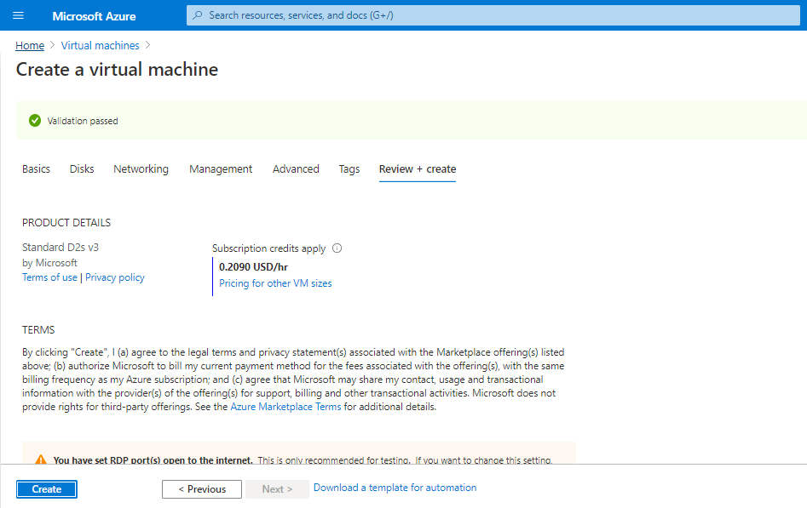

Your Virtual Machine will get deployed.

